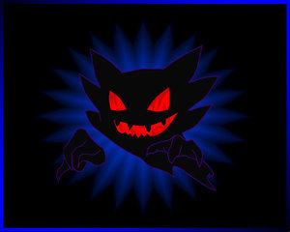

Dark Hunters……..Gotta Cacth’em all!

The Unicorn Faction Presents.



Silverwood Scout Camp
Barnsley Road, Silkstone. Barnsley. Barnsley

2nd November – 4th November 2007

A Lorien Trust Sanctioned Event

Rules and Regulations of the Unicorn Faction.

- The Unicorn Faction or any persons so appointed by The Unicorn Faction cannot be held personally liable or responsible for any injury or damage to any individual participating in any The Unicorn Faction event.

- The Unicorn Faction cannot be held responsible for any damage to, loss or theft of any personal or communal property during any The Unicorn Faction event.

- The Unicorn Faction are NOW operating a strict ‘NO CARD. NO EFFECT’ policy. Any and all special items, poisons etc must be disclosed prior to booking. There are NO exceptions to this rule.

- LRP is a potentially dangerous hobby and I agree to act in a reasonable and safe manner during any LRP event.

- I understand and agree that The Unicorn Faction reserves the right to refuse admission or participation in any event or part of an event to any individual at any time. The organisers are not obliged to give any reason or explanation for such a decision, but one can be supplied after a request in writing.

- Metal weapons or tools are NOT to be carried on site. Camping knives may only be carried in direct proximity to allocated camping areas.

- The organisers will expel any individual engaged in illegal, defamatory or dangerous practices during the event ‘it’s funny is not an excuse!’

- The Organisers decision is final in all disputes.

The Unicorn Faction and Unicorn Faction Command use the Lorien Trust LRP version 3.0 Rules System. The Lorien LRP System is copyright to the Lorien Trust 1996
Arrivals

When you arrive on site please report to Games Operations. All areas will be clearly signposted. You will be able to pick up your event character card and any other information when you book in. All players, monsters and staff MUST register on arrival.

When parking your vehicles please make sure you are leaving all access areas clear. Please remember to put your parking voucher in the window of your vehicle. This is also for security reasons and shows you are authorised to be on site. If there is no-one there then use your common sense and park the same as the other cars. If in doubt find a member of staff. If you need to bring your car closer to the camping area clear it with the event organisers upon arrival.

Welcome to Unification!

Before going IC, please take time to read the IC paperwork included with your character card. This will give you a flavour for the trials and tribulations to come and may also provide the odd little hint to help you survive the event!

When you are ready to go IC please see Games Operations who will advise the details on how and where this can happen….not that anything bad could happen…..honest!

A reminder. NO CARD, NO EFFECT.

If your card is not logged with event organisers then, in terms of the event, it does not exist thus using any of the abilities granted by the card. If you have booked without enclosing copies of lammies (all lammies) that you intend to use at the event, please declare them when you book into games ops.

Above all, have fun and stay safe!
STAFF

Event Organiser. Rob Smith

Sanctioning Officer Taryn Donnelly (Taz)

Event NPC’s Steve Light,.Chris Waite, Rob Smith, Pete Godfrey

Plot Peter Godfrey

Weapons Checkers. Steve Light

Refs Steve Light, , Pete Godfrey, Rob Smith, Chris Waite, Lauren Orton, Russell Barnes,

Games Ops Pet Light, Tyron Couch,

1st Aid Sarah Tomlinson, Lauren Orton

Fire Safety Steve Light, Chris Duchesne

General Staff Jay Wilson, Gareth Holmes, Lauren Orton, Pet Light, Alan Williamson, Jacqui Archer, Eddie Hallahan
A HUGE thank you!

Well, this year has been an eventful one to say the least!

There is never enough space to thank everyone but here goes.

A huge thank you to Steve, Doc and Pete – you guys always amaze me with the amount of hard work you put in and the late nights and early morning you all endure, still with big smiles on your faces! You’re the best NPC team out there and I wouldn’t do this job without you!

Monsters & Staff – Without you this event would simply not have happened. Thank you to every single one of you for the hard work you’ve done leading up to this and the hard work you’re going to do over the weekend (and for all the paggerings you’re going to get in the case of the monsters ;) )

A massive thank you to all the unsung heroes who put in the hard work that makes this faction the best in LT! From the props makers, plot monkeys and set up crew, all the way down to those of you who make sure all of the NPC’S get fed (You all know who you are!)

Here’s to an amazing event and many more to come!

THANK YOU VERY MUCH

Rob
The Bar

We will as usual be operating a bar selling a variety of alcoholic and soft drinks (Including the now infamous mulled wine!), snacks and sweets. Purchases from the bar must be made using Scrips which can be purchased from Games Operations or from Pet Light or Sarah Tomlinson.

Monsters.

Monsters will be sleeping inside but please bring something suitable to sleep on (Air Bed, Roll Mat, etc). Please bring appropriate bedding with you. We will be providing evening meals for all of the monster crew. A food ticket for the remaining meals will also be available from Games Operations at a cost of £12.

You will also be able to have Tea, Coffee, and snacks on a help yourself basis all day. All monsters can arrive on site from 11.00 am on Friday. Staff will be sleeping in bunks provided so only bedding is required. Limited food will be provided for staff

Directions.

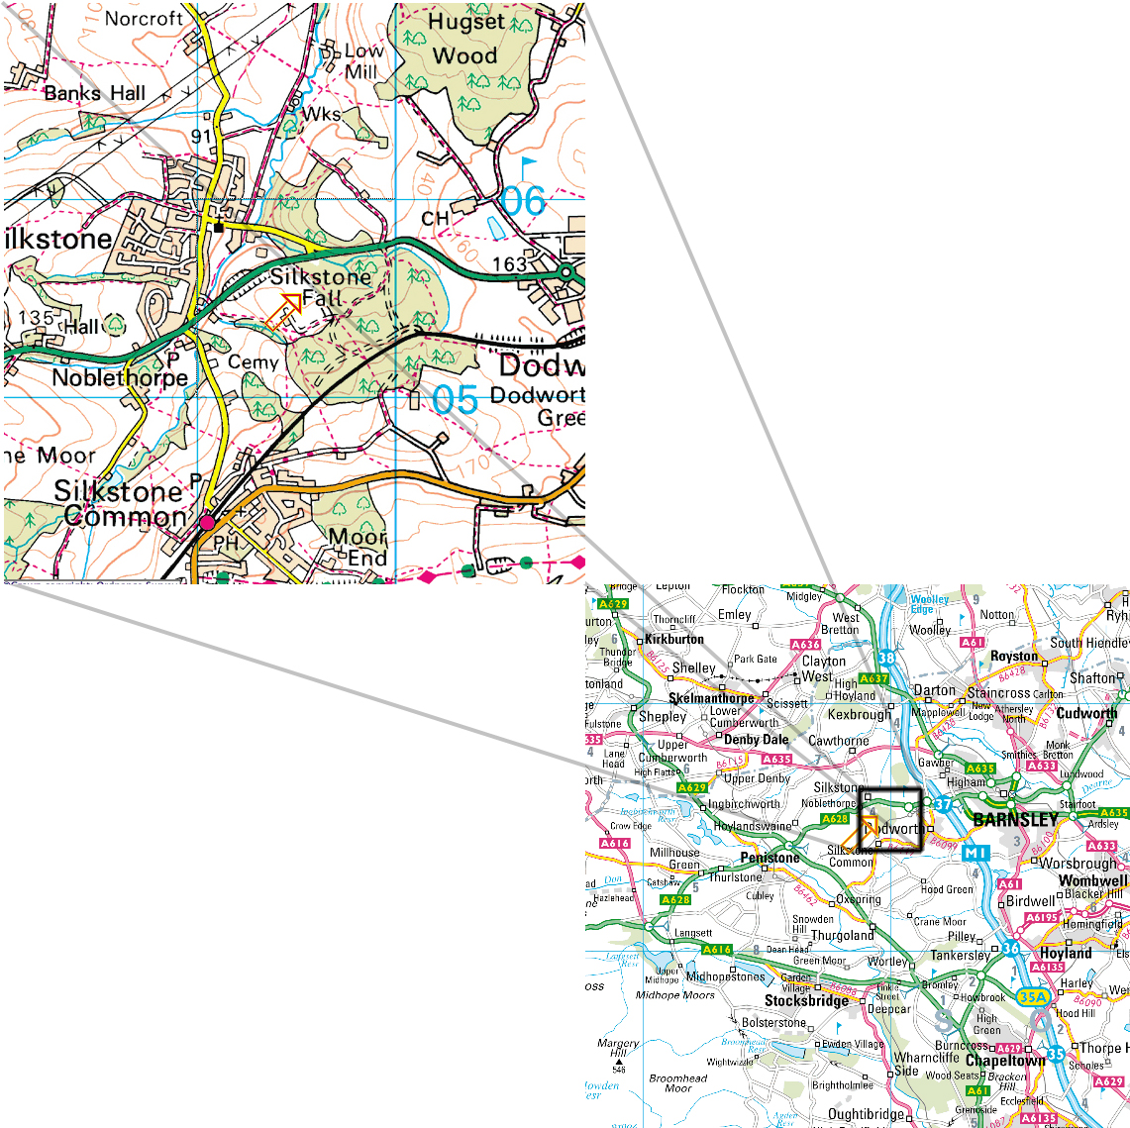

Leave the M1 at junction 37, then at roundabout take the exit onto the A628 (signposted Manchester) then follow signposts marked LRP

Via Train: Head for Barnsley Station

Taxi Number: Blue line Taxis 01226 244444

TIMETABLE

Friday Arrivals 2.00 pm

Time in 5.00 pm

Time out 2.00 am
Saturday
Time in 10.00 am

Time out 2.00 am

Sunday

Time in 10.00 am

Time out 3.00 pm

When leaving the site please help us to make sure the site is clean and tidy.

Please take a moment to make sure all of your rubbish is properly bagged up and placed in the correct area. Rubbish bags will be available at Games Operations.

All players must be off site by 5pm and all buildings must be vacated by 4pm

Catering

Catering for this event will be provided by The Banquet Club. They come very, very highly recommended and their meals sound delicious! See below for a menu. Meal tickets are available from Games Operations and only cost £20 for the whole weekend.

Friday Evening
Beef in ale with dumplings
Caledonian stew and bread
Mushroom stroganoff and bread
Tudor gingerbread
Saturday Breakfast
Cereal or porridge with jam / milk / dried fruit
Sausage sandwiches
Fruit
Saturday Lunch
Bacon and bean stew
Veggy bean stew
Chicken and vegetable soup
All served with Welsh rarebit
Saturday Afternoon
Bara brith (traditional Welsh tea bread)
Cheese
Apples
Saturday Evening
Chicken portions and sauce
Irish stew
Pear and chestnut crumble
All served with champ (Irish mashed leek and potato) and peas
Cloutie dumpling (steamed fruit pudding) and custard
Sunday Breakfast
Cereal or porridge with jam / milk / dried fruit
Sausage sandwiches
Fruit
Sunday Lunch
Pasties
Crisps
Chocolate

